**Docker hub repo with image tags**

1. dev repository

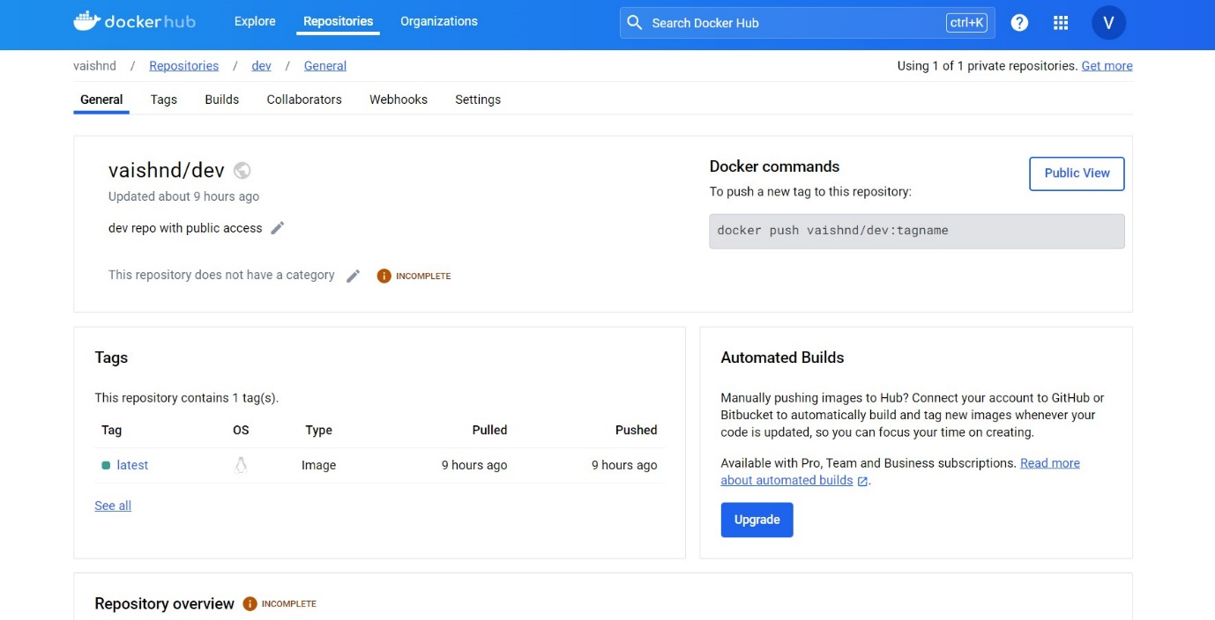

1. dev repository image tags

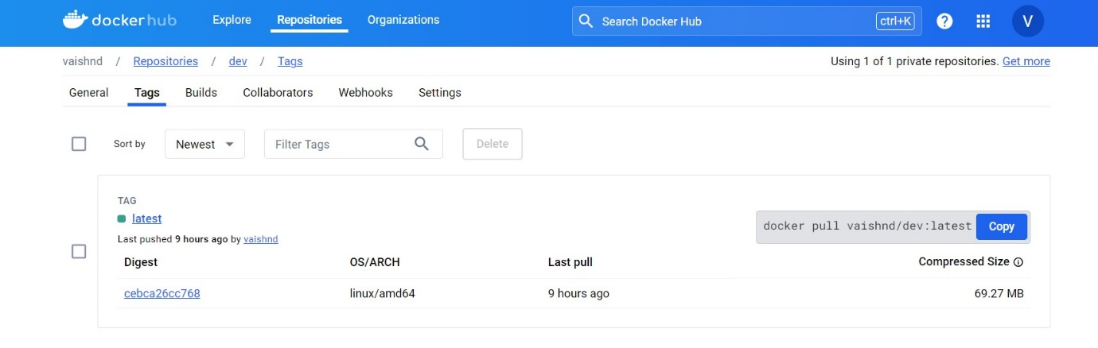

1. Prod Repository

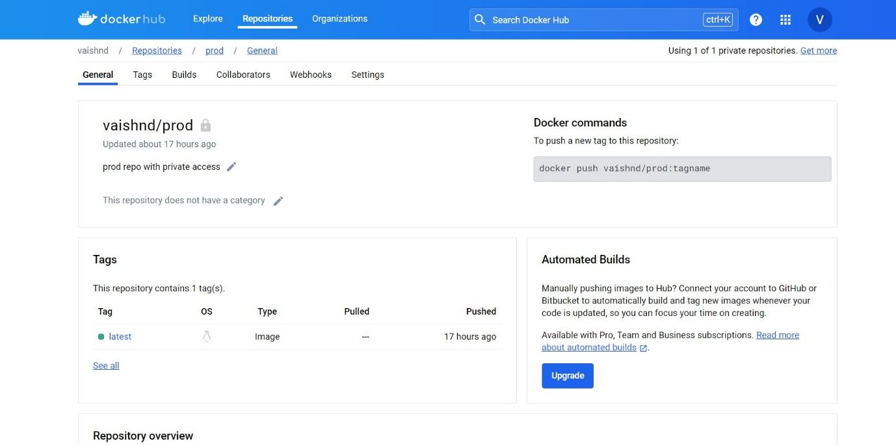

1. Prod repository image tags

